Eucalyptus Bowl Coaches Pack 2024
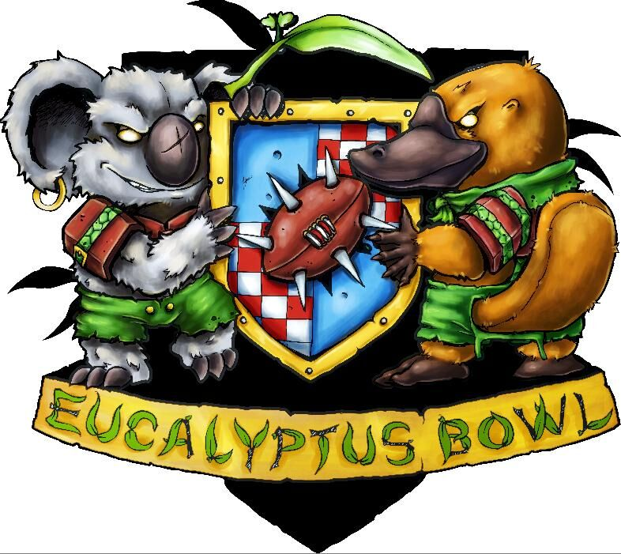

Eucalyptus Bowl is continuing to go strong – despite the evil COVID’s interruption in 2020. We had a nice boost in numbers in our recent years and I am hoping that we can continue to grow. As of 2019, we became the Australasian Major. We now sit alongside the Spike Magazine Trophy (Canada), Dungeon Bowl (Germany), Chaos Cup (USA) and NAF Championships (UK) as non-Teams tournaments that attract the maximum Rankings points in the NAF Tournament rankings database.
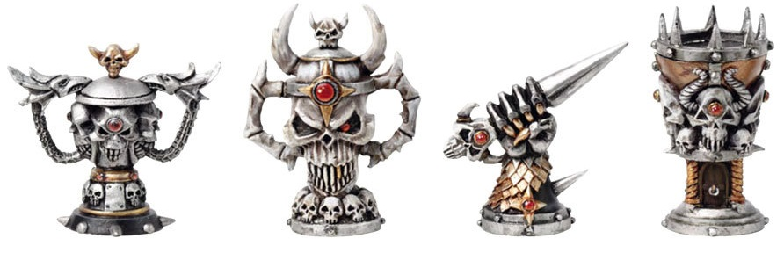
Check us out on Facebook for all the latest news and announcements.
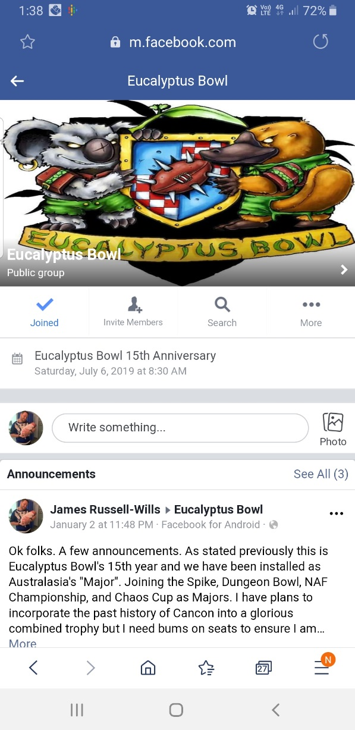

Where: Club Burwood RSL Club, 96 Shaftesbury Rd Burwood, Sydney, Australia
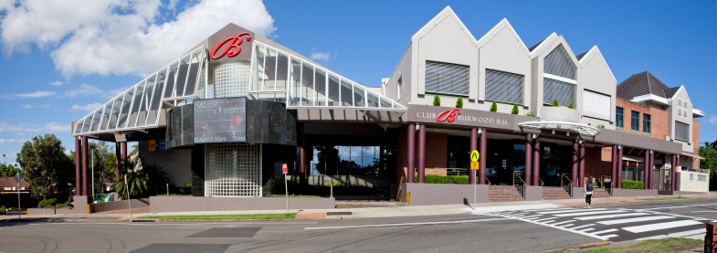
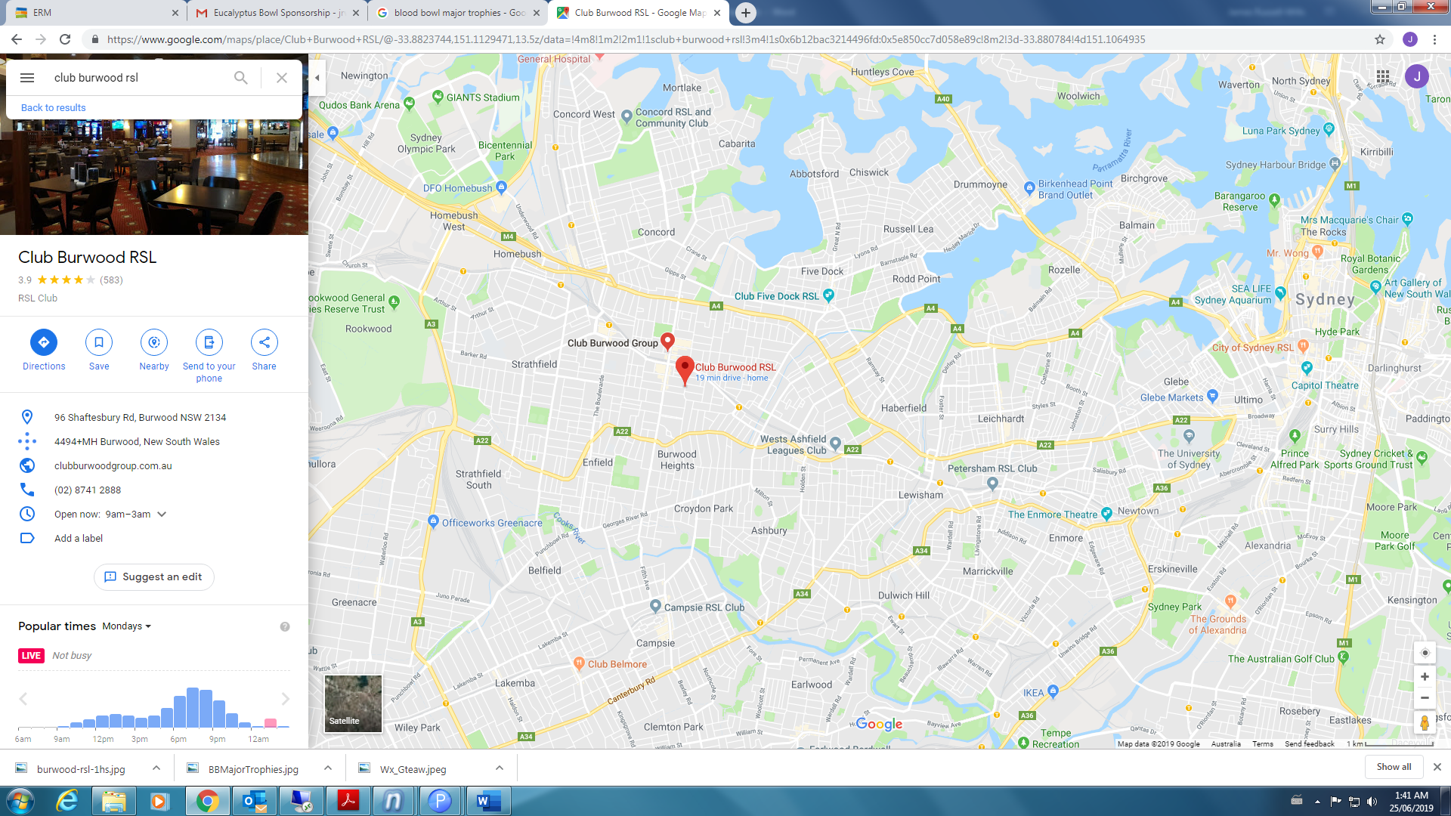

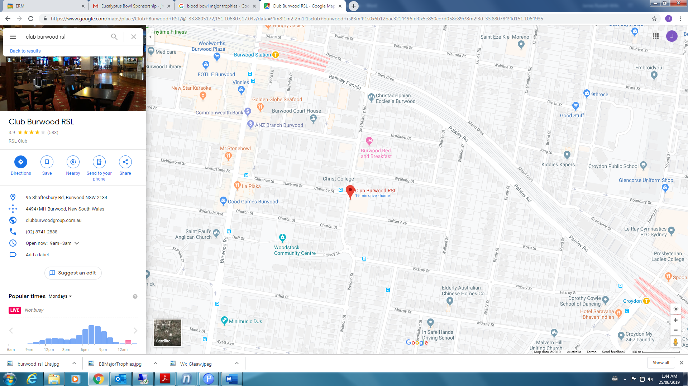

When: 13th & 14th July 2024 from 08:30-17:30 each day
Schedule:  Saturday  Club Entry: 08:30  Registration: 8:30-09:00  Game 1: 09:00-11:15  Game 2: 11:30-13:45  Lunch: 13:45-14:30  Game 3: 14:30-16:45 | Sunday  Club Entry: 08:45  Game 4: 09:00-11:15  Game 5: 11:30-13:45  Lunch: 13:45-14:30  Game 6: 14:30-16:45  Prize Giving: 1700-1730

Each Game is allocated 2 hrs and 15 minutes. The T/O reserves the right to call any games that run over time and determine the likely outcome of the game. Players who the T/O determines are consistently playing slowly to the detriment of their opponents may have results overturned or tournament point penalties imposed. Players are asked to download a Chess Clock App on their phones for potential use in the tournament. Chess Clocks that are used at the start of the game should have 1 hr and 5 mins allocated to each player. If with 1 hr remaining you and your opponent have not commenced the 2nd half, chess clocks are mandatory. In this instance 30 mins should be allocated to each coach. Should you run out of your allocated time while using a chess clock the official tournament ruling is that all you can do is stand up prone players and roll over stunned players. If one of your players is holding the ball they are able to make a move action that requires no dice rolls. I.e. No dodging, no rushing etc. Gentlepersons agreements are permitted in that your opponent may graciously allow you to play as normal as long as the round has not been called, however they are under no obligation to do so and should not feel bullied or pressured in any way. In coming to Eucalyptus Bowl, players agree that the T/O will apply reasonable and fair rulings to the best of his ability.
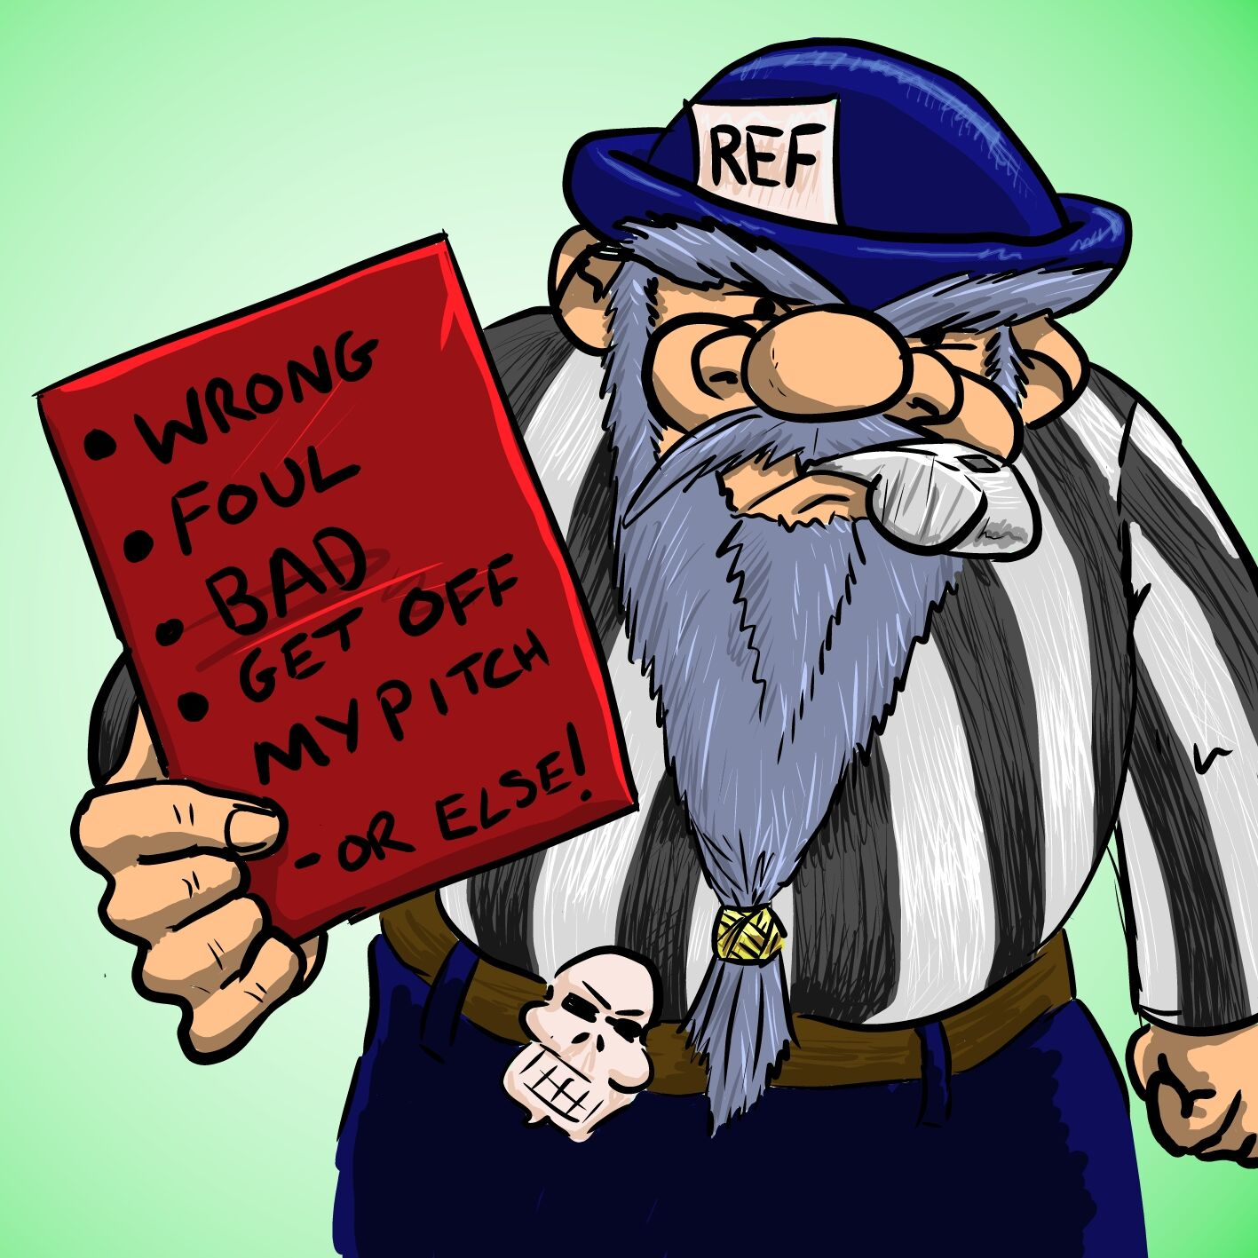
Costs:
The Cost of EucBowl will be $60 (With an early bird rate of $50 if prior to Feb 29th).
Bring a friend/1st Timers Discount: If this is your first Euc Bowl you can take a further $10 off the ticketed price and you can also nominate a veteran coach and they will receive $5 off their entry (One Veteran discount per Coach)
New to NAF: As an added bonus to first timers. I am offering discounted NAF membership for $10 (usually $15) which includes a choice of gifts (inc. Dice, Markers etc)
Cost Break Down
$60 (Returning Coach, payment after Feb 29th) (New Coach, payment after Feb 29th, NAF Membership included)
$55 (Returning Coach, payment after Feb 29th, Bring a Friend Bonus)
$50 (Returning Coach, payment prior to Feb 29th) (New Coach, payment Prior to Feb 29th, NAF Membership included)
$45 (Returning Coach, payment prior to Feb 29th, Bring a Friend Bonus)
$40 (New Coach, payment prior to Feb 29th)
For Payment details please just use the same account as last year or send me a PM on Facebook. My preference is for bank transfers, but If you would prefer it Paypal is available.
One Day Tickets are not available this year, but players that can only attend 1 day are invited to share a ticket with a coach who can only play on the other day.
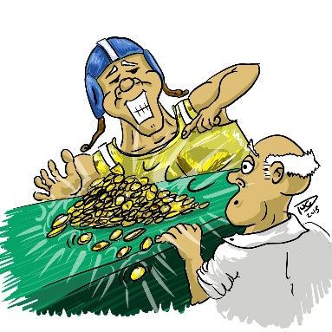

What to Bring:
Your Team (obviously). We ask that you bring a painted team (minimum 3 colours) full coverage of the miniature, or clear shading if you are going for a monotone look and this is thematic to your team. Please if you don’t have a team ask to borrow one instead of ruling yourself out of coming. You will find Blood Bowlers are a very generous community and many of us have far too many teams, you are bound to find someone with the race your heart desires to play. Boards and Dice are the key ones. If you don’t have a board, relax, chances are that you won’t need one as if only half the attendees bring boards, we have got you covered. Any templates such as scatter and pass are handy but we have ways around them. A penalty of -10 tournament points may be applied for each game played by a team deemed insufficiently painted at the T/O’s discretion.

Rules:
We are using the new BB2020 Rules for Tournaments as per the NAF website: https://www.thenaf.net/wp-content/uploads/2023/12/NAF-Rules-for-Tournaments-2024.pdf, as adjusted by the errata documents https://www.warhammer-community.com/wp-content/uploads/2017/11/P9GJXUTdGyGDeZkk.pdf
Please note that any team that has seen a new release will now only be using new rules and this overrides the roster found in the Teams of Legend document.
The newly released gnome team is available to be used.
Wizards are permitted as per the BB2020 rule book (it’s a fireball or frog zap), as are all inducements as per the BB2020 rulebook, Death Zone and Spike Magazines. (I reserve the right to disallow certain inducements such as Giants and Mercenaries, so if you are using inducements please get in touch with me prior to roster creation for approval).
If you have any queries prior to the tournament or during, don’t hesitate to ask.

Team Build:
All teams have a value of TV 118 - TV 135. i.e.1,180,000 and 1,350,000 GPs to spend. With Tiering Returning to Euc Bowl please take note of the below:
Race hasn’t won a Euc Bowl or a Stunty King (+2 TV)
Tall Poppy Penalty (-2 TV) for last years Champion Race and Stunty King.
Stunty teams are: Goblins, Ogres, Snotlings, Halflings, Gnomes, Skinks (no Saurus), Underworld (no Skaven- but Big Guys allowed), Black Orcs (No Black Orcs)

TIER 1 (120 TV) | Tier 2 (125 TV)
Amazon | Black Orc (127 TV)
Chaos Dwarf | Imperial Nobility (127 TV)
Dark Elf | Chaos Chosen (127 TV)
Dwarf | Chaos Renegade (127 TV)
Lizardmen | Elf Union (127 TV)
Necromantic Horror | High Elf (127 TV)
Orc (118 TV) | Human (127 TV)
Shambling Undead | Khorne (127 TV)
Skaven (122 TV) | Norse (127 TV)
Underworld Denizens (122 TV) | Nurgle
Wood Elf | Old World Alliance
 | Slann
 | Tomb Kings (127 TV)
 | Vampire (127 TV)
 | (First Euc Bowl Tier 1 – 125 TV)

Stunty (135 TV)
Gnome (137 TV)
Goblin
Halfling
Ogre (133 TV)
Snotling (137 TV)
Underworld – No Skaven (137 TV)
Lizardmen – No Saurus (137 TV
Black Orcs – No Black Orcs (137 TV)

•The gold can be spent on any combination of players, inducements and skills as allowed by the Ruleset. NOTE: We are NOT using the full Prayers to Nuffle table (the one used in league play, pg 39 of the BB2020 rulebook), We WILL use the abbreviated Prayers to Nuffle table for those Kick-off events that refer to rolling on the Prayers to Nuffle table (pg 103 of the rule book).
◦All teams must start with at least 11 players (this can include star players)
◦You must spend all your cash, or discard unspent funds. You cannot keep unspent funds in your treasury and spend it later.
◦Unless you spend GPs on them your Dedicated fans will be considered 0 for your team.
*Each rostered player can be given at most one Normal skill, increasing their value by 20k
*Teams are limited to the following Skill Caps (i.e. Max number that a particular skill can be chosen.
General: 4 (i.e Max 4 added Block skills)
Strength: 2 (I.e Max 2 added Guard skills)
Agility: 4 (i.e. Max 4 added Dodge Skills)
Passing: No Restrictions
Mutations: No Restrictions
*Euc Bowl will be running with the following house rules re: Star Players
- There is a 50K Tax for every star player rostered on your team
- Teams can only have 1 Star Player (or rostered pair Stars) on their team (Stunties exempt and allowed 2 Star Players)
- We will be playing a modified Highlander Rule. If you and your opponent are fielding the same star player, he/she will not take the field for either team. Instead the teams will scramble for a journeyman replacement to fill this position, based on that teams allowed journeyman position.
I am seeking to reduce the use of Stars while not banning them completely. I believe Stars are currently undercosted and overpowered in this ruleset. I am seeking to replicate a modified tiering seen in a few international tournaments by applying this TAX. In essence a non stunty team taking a star will be playing at 120 TV while a Stunty team that takes 2 stars would be on the same TV 125 as the non stunty teams.
With that Said. The following Star Player – Skitter Stab-Stab is currently banned from the tournament. It is my hope he will be re-costed in the next designers commentary. Should this occur between now and the tournament I may rescind this decision.
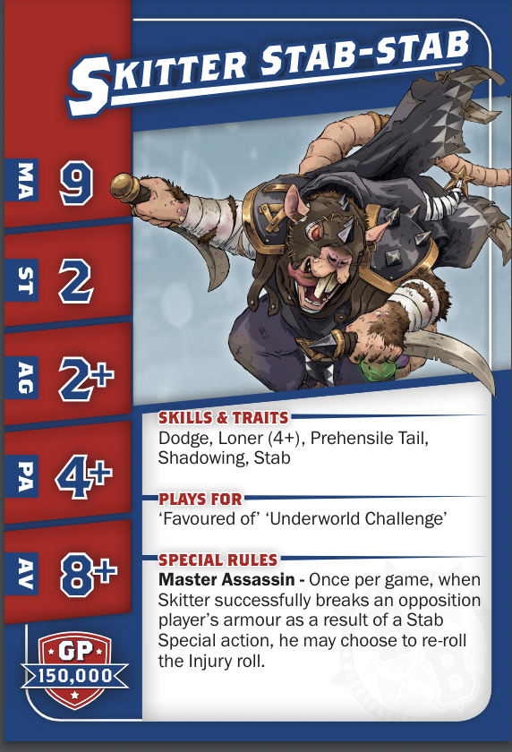
◦Star Players are not eligible to gain additional skills.
◦Only the teams listed in the BB2020 rulebook, GW Spike Magazines and the teams of legend document can be used: https://www.warhammer-community.com/wp-content/uploads/2020/11/lFZy1SIuNmWvxPj1.pdf . With the Amazon, Norse and Vampire rosters in the TOL document superceded by Spike Magazine rosters. This includes Slann as listed in the tournament document (link above).
So in case that isn't clear. Euc Bowl remains a tournament without a skill package. You have GPs to spend on players, inducements and skills. The skills are limited to 1 per player (Star Players ineligible) and cost 20,000 GPs. On top of this, for any skills purchased in this way you are limited to only be able to select a certain skill as per the skill caps. Obviously, players starting skills are not affected by this. This is an attempt to reduce the spamming of certain skills, e.g. Mighty Blow, Guard etc and hopefully make a few more teams attractive to take, and make all teams just a bit more diverse.
Rosters will be required to be sent to me 1 week prior to the tournament. Any Rosters that miss this cut off or are brought in on the day will require at least two dedicated fans to be incorporated into the team. They will still need to be whichever applicable TV, but for some rosters this could have a very negative effect on what you are trying to build.
The ruleset while established could be a little convoluted for some coaches, and I want to make sure everyone has a valid roster.
This is an attempt to encourage early submission of rosters without breaking the system.
They can be sent to eucalyptusbowl@gmail.com
The Deadline is Sunday 7th July at Midnight. Any Rosters in after this time will require the minimum two fans and the coach will not be eligible for any best in race prizes.

Euc Bowl Bingo:
Eucalyptus Bowl generally gets a diverse range of teams due to the fact you can win Best in Race for your chosen team. However as is often the case, sometimes the ruleset will just suit a certain Meta. I am not someone that wants to tinker with the rules from year to year, I want players past, present and future to know what to expect when team building for Euc Bowl. With the re-introduction of Tiers, and adding a degree of balancing to the system, as well as incorporating an encouragement for Teams that have never won Euc Bowl (The equivalent of 1 extra skill) and punishing last years winners (the equivalent of -1 extra skill). I wanted to add something small which may encourage even further diversity, and prevent players all playing the same race due to a favourable Meta.
I humbly introduce the following Eucalyptus Bingo Cards that will be available for single use during rounds 1-5 (i.e. they wont effect the all important final round).
For the coaches that select the 3 most represented races you will recieve the Band Wagoners Bingo Card (which your opponents can during their game with you select to activate one of the 5 available options.) This will then be crossed off and will not be available in future rounds. In otherwords the options for use each round will diminish throughout the tournament.
Band Wagoners:
- Euc Brew - Opponent can add +2 to a single KO roll they make
- Euc Flowers - Opponent can add a -1 to a single Armour Roll made by you against one of their players
- Euc Roots - Opponent can add a -1 to a single GFI/Rush Roll made by you.
- Euc Crowd - Opponent can Elect to have the Fans on their side. This can be decided after Fans have been rolled to reverse the result. Instead for any Kick Off results that refer to FF, you are considered to have a FF of 0, and your opponent a FF of 1. If both coaches carry this bingo card and choose to use this option, the coach who “lost” the fans roll would need to decide first. For a drawn fan roll, both coaches using this means it stays a drawn result.
- Euc Bribe - Opponent can reroll an Argue the Call Roll they make (This cant result in the same Argue the Call roll being rolled 3 times through use of specific inducements or team special abilities)
And for the 3 least represented teams you yourself will recieve the Under Dogs Bingo Card. This works in a similar fashion to the Band Wagoners Card except that you get to apply the options to your own team rather than your opponent using it against you. It is a one per round power, and once used isnt available for future rounds.
Under Dogs:
- One Eyed Ref - You can make a 2nd foul action in the same turn.
- Rabid Crowd - You can choose the direction the ball will go when kicked in by the crowd. This will apply for the entire game.
- I'm a Euc Bowl Star ! - Just prior to resolving Kick Off (After both teams have setup) Choose a general skill and then Randomly select a player on your team and add the skill to that player. This can give that player a second skill. You cant reroll, so if the player already has this skill it is wasted. Skills do not stack, i.e. Mighty Blow becoming +2 on a player that already has Mighty Blow. Star Players are not eligible and the roll will also be wasted if they are randomly chosen. This extra skill will remain for the current drive only.
- Team Captain - Just prior to resolving Kick Off (After both teams have setup) Choose any player on your team and then Randomly roll on any primary skill tree available to that player and add the skill to that player. This can give that player a second skill. You cant reroll, so if the player already has this skill it is wasted. Skills do not stack, i.e. Mighty Blow becoming +2 on a player that already has Mighty Blow. Star Players are not eligible. This extra skill will remain for the current drive only.
- Big Moment - Before a single 1 Dice Roll you can declare this roll as your Big Moment. If this roll fails, you can reroll it. Note that Skill Rerolls or Team rerolls cannot be used on top of this reroll.
As with most of Blood Bowl, the majority of rolls made can be made after seeing the Dice Roll before choosing to use the ability. The obvious exception being the Big Moment. Other Abilities such as Euc Crowd and Rabid Crowd need to be chosen at the start of the match. Im a Euc Star and Team Captain can take your team beyond the skill caps as set out in the Team Build section. The T/O reserves the right to determine which teams trigger the Bingo cards based on the balance of racial make up of the tournament.

Tournament Scoring:
Win = 80 Points
Draw = 40 Points
Loss = 10 Points
All Tiebreaking is done using Strength of Schedule (SOS) Which will be the accumulation of all your opponents Tournament scores. In the case you have played an opponent that doesn’t play all 6 games over the weekend you will receive SOS score increments equivalent to their average tournament score per game for each game they did not play. In the case of players being equal after review of SOS, Head to Head result if applicable will be used, followed by a simple Most Wins priority, then an accumulated TD and CAS score using a 1.5/1 weighting. Note this is simply TDS scored and Casualties caused and is not affected by received values. In the unlikely event players are still equal after this, the T/O reserves the right to award Joint Winners.
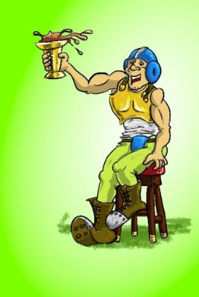
Prizes:

Winning coaches will receive any/all physical trophies due to them, followed by one pick from the prize table. If someone wins multiple physical trophies when that prize is up the next person down the line will receive that pick from the prize table. Prizes will be awarded in the following order (and will include any applicable best in race medals):
- Champion
- Stunty King (Highest placed Stunty eligible team)
- Best Painted Team (Voting will take place on the Sunday and will be a popular vote format unless a painting judge can be found)
- Best Newcomer (Available for a Euc Bowl 1st timer)
- Runner Up
- Third Place
- Most Touchdowns
- Most Casualties
- Most Kills
- Remaining Best in Race Medals
- Any Remaining prizes will be awarded based on highest place getter’s still left who haven’t chosen from the prize table

Please note that after the major trophies are awarded along with any applicable best in race medals for those coaches, the remaining best in race medals will be awarded. These will be awarded based on the following criteria.
- Least represented race
- Highest Placed team

e.g. We have a ten-team tourney with the following places:
1st – Orcs 2nd – Dwarves 3rd – Orcs 4th – Humans 5th- Dark Elves
6th- Humans 7th – Humans 8th – Dwarves 9th – Nurgle 10th – Halflings
In this example prizes would be awarded to Orcs as Champions along with Best in Race for Orcs.
Followed by Halflings as Stunty King with best in race for Halflings.
Runner up Dwarves with best in race for Dwarves
3rd Place Orcs
Best in Race Dark Elves (5th)
Best in Race Nurgle (9th)
Best in Race Humans (4th)
The aim of this is similar to our move towards tiering and an attempt to encourage diversity and playing of some lesser loved teams.

Come on down and support Blood Bowl in Australia.
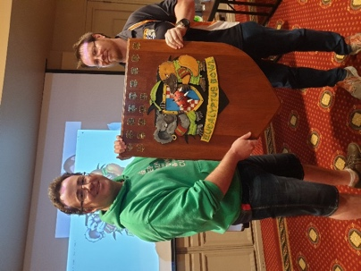

For More Information on the Blood Bowl Tournament Scene in general go to www.thenaf.net
